

Bachelor Degree in Industrial Engineering

Thesis Title

Supervisor |  | Student
Prof./Dr. Name and Surname |  | Name and Surname
Co-Supervisor |  | Registration Number
Prof./Dr. Name and Surname

Academic Year ……

“With the hope that the editing of this thesis could be for you a moment of personal, cultural, and professional growth”.
Your travel companion.
Prof. Valerio De Santis

NOTE: the thesis dedication is not mandatory and must be personalized!

Acknowledgments
Normally, the first pages are dedicated to the acknowledgements, where the authorship indicates the person or the institutional organization that did not have a direct hand in producing the work in question, but may have contributed funding, criticism or encouragement to the author. Sometimes, a special dedication or a famous quote comes before the acknowledgments section.
Alternatively, the acknowledgments can be placed even and the end of the work.

Preface
The following document provides some guidelines for the editing of the Bachelor Thesis in Industrial Engineering from the University of L’Aquila. In the engineering field a technical-scientific form of writing is preferred. The scientific writing is that kind of prose that is used to communicate concepts in a clear and concise way without any ambiguities.
The form, in the thesis editing, does not have a minor importance of contents; therefore, it is very important to respect editorial rules. Grammar syntax and punctuation of the chosen language must be respected. As concerns the choice of the personal pronoun, it is advisable to use the impersonal one or alternatively the first person singular, but the first-person plural should be avoided. For the sake of clarity, it is a good practice adopting an appropriate sentence length, possibly around 20-25 words or not longer than 3-4 rows. Do not make a massive use of the italic, bold, and underline fonts, as they should be used only to emphasize the key words. Also, the use of footnotes should be avoided, unless it is extremely necessary. This is because it makes the reading of the text heavier for the reader, even if in this document it is widely used, but only for didactic purposes.
The aim of this document is to save precious time while maintaining a high-quality technical result. It contains several guidelines related to either the text format and result presentation, and to the thesis chapter organisation. Therefore, this document can be used as a template for the thesis itself.

Index
Afterwards, the content index or the table of contents is reported, together with the list of figures and tables. These can automatically be updated if a proper use of the “cross-reference” tool is made, as in the following explained.
Even in this case, the list of figures and tables could alternatively be reported at the end, after the conclusions and before the list of symbols and acronyms.
Table of contents
Acknowledgments i
Preface ii
Index iii
List of figures v
List of tables vi
Introduction 1
Thesis subject 1
Thesis aim 1
Thesis outline 1
Chapter 1 Numbered chapters 2
Chapter 2 Thesis writing 3
2.1 Layout and editing 3
2.2 Section titles 5
2.3 Figures 7
2.4 Tables 9
2.5 Equations 11
2.6 Lists 12
2.7 Acronyms 13
2.8 Bibliographical references 13
2.8.1 Harvard style 14
2.8.2 IEEE style 15
Chapter 3 Final recommendations 16
Conclusions 18
Future works 18
List of symbols 19
List of acronyms 20
Bibliography 21
IEEE Style 21
Harvard style 23
Webliography 26
Appendix A Numbered appendices 27
Appendix B Mathematical treatment 28
B.1 Theorems 28
B.1.1 Corollary 28
Appendix C Numeric codes 29
C.1 Matlab code for the calculation of the Hysteresis cycle 29
C.1.1 Main Function of Jiles-Atherton (JA) model 29
C.1.2 Function Jan_loops 30
Appendix D Experimental measurements 32
D.1 Performed measurements 32
D.2 Uncertainty analysis 32
Appendix E Technical drawings 33
E.1 Support basement 33
E.2 Shell 34
Appendix F Circuit Diagrams and Layouts 35
F.1 Circuit diagrams 35
F.2 Circuit layouts 36
Appendix G Chemical processes 38

List of figures
Figure 2.1 – Margin settings 4
Figure 2.2 – Paragraph formatting 5
Figure 2.3 – Cross-references for the automatic numbering of sections 6
Figure 2.4 – Comparison between the hysteresis cycles based on experimental data and numerical model reported in the Appendix B for a doped Fe-Si at 3%. Figure from Grimaldi (2020) 7
Figure 2.5 – An example of picture with a readable (a) and not readable (b) text 8
Figure 2.6 – Settings needed to lock the figure aspect ratio 9
Figure 3.1 – Settings to enable the spelling and grammar check 17

Figure B.1 – Settings for automatic numbering of Figures in the Appendix 28

Figure E.1 – Drawing 1: support basement 33
Figure E.2 – Drawing 2: shell 34

Figure F.1 – Circuit diagram 35
Figure F.2 – Circuit layout: (a) TOP view; (b) BOTTOM view 36
Figure F.3 – Detailed view of the prototype board. 37

List of tables
Table 2.1 – This is a table template with few columns 10
Table 2.2 – This is a table template with many columns and data 10

Table D.1 – Example of carried out measurements 32
Table D.2 – Example of uncertainty analysis on the carried out measurements 32

Table G.1 – Example of reactions that happen in a chemical process 38

Introduction
The introduction must focus the attention on the main topic of the thesis and must explain the fundamental aspects of the work done, underlining the aim. The introduction must also contain the thesis structure presented in a clear way, with a brief description of the chapters.
The state-of-the-art and the theoretical background of the investigation field instead deserve a comprehensive review in the first chapters.
The introduction is therefore composed by the following three unnumbered sections:

Thesis subject
Here, the main topic of the problem is illustrated.

Thesis aim
Here, the target that is intended to be achieved with the thesis work is described.

Thesis outline
Here, a brief summary of the chapter's content is presented.

Numbered chapters
Below the introductive unnumbered chapter, an outline of the thesis methodologies must be presented in the numbered chapters. After a careful literature review and analysis of the technological context, the main mathematical formulation and the eventually developed or to be tested processes should be described in these chapters. For numeric-experimental theses, it is also required a description of the research tools (hardware, software and/or technical instruments) and the employed procedures. Finally, it will follow the presentation of the results and their discussion, with the aid of graphics and tables.

Thesis writing
In this chapter, major information about the main text, chapters, sections, and sub-sections layout will be given. In addition, instructions for the correct insertion of figures, tables, equations, lists, acronyms, and bibliographic references are also provided.
  - Layout and editing
The thesis must be written using UNI A4-size pages. It is suggested the following:
- Margins: upper, lower, and right margin of 2/2.5 cm, with 1 cm of binding at left.
- Font: Times New Roman with 12 pt dimension, or other fonts with similar dimensions.
- Line spacing: 1.5 lines with a spacing of 6 pt after each paragraph, as settled in this document; it can be even left out, especially when the paragraph indentation is used at the beginning of each paragraph.
- Text alignment: justified in the main text, while in the figure caption and in the table header, it should be used the centered sentence.
- Footer: insert only the page numbering (using the Arab numbers) with a right-alignment, starting the numbering from the first page of the Introduction chapter. The roman numerals should be limited to the previous pages of such a chapter.
- Header: it can be left empty or it can contain the chapter title right-aligned.

These settings have already been settled in this document, but some example screenshots are shown in the following for the sake of clarity.

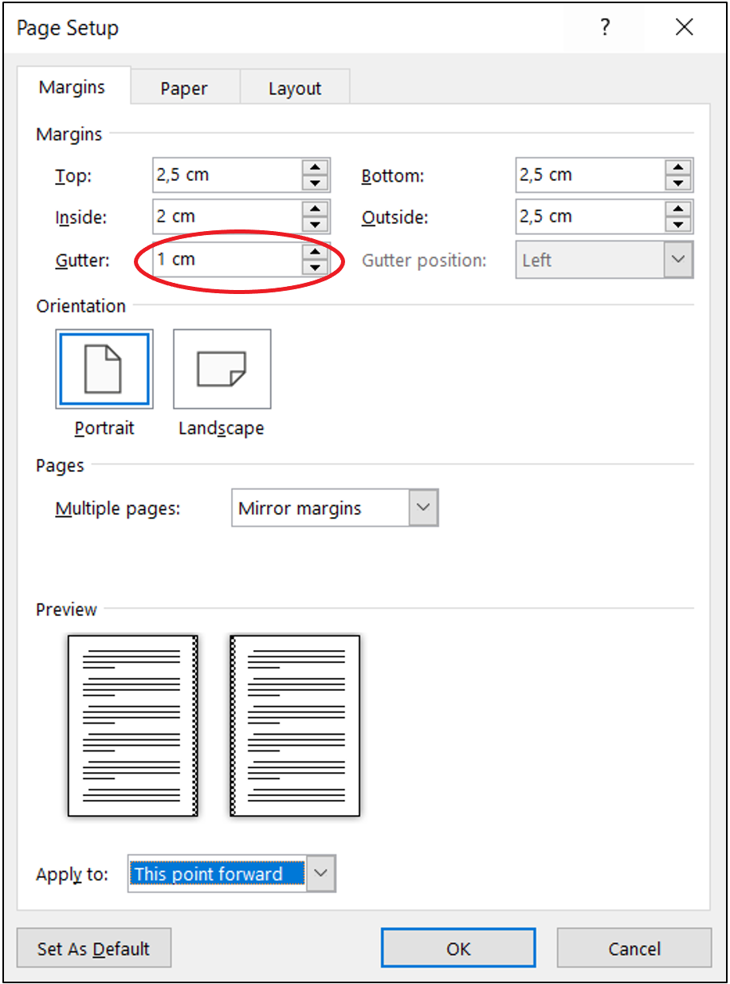
Figure 2.1 – Margin settings

The window in Figure 2.1 can be obtained with a double click on the ruler that appears at the top/left of the working page, or using the ‘Layout Margins Custom Margins’ tool.
Similarly, the settings related to the paragraph formatting can be changed by using the ‘Home Paragraph setting’ tool, as shown in Figure 2.2.

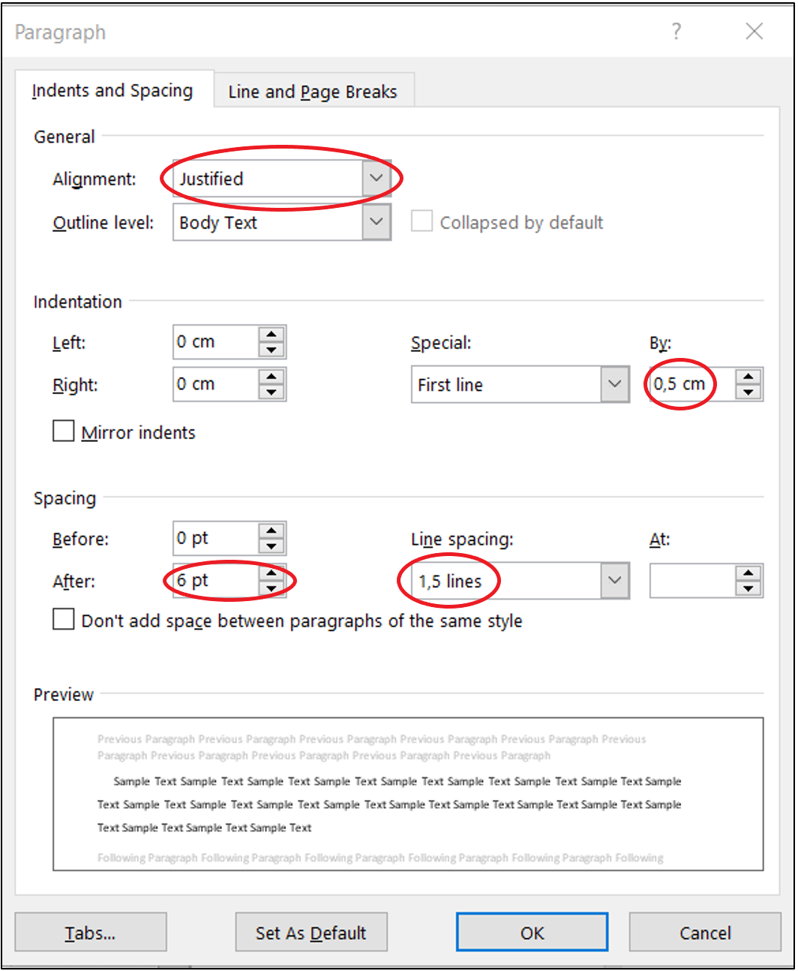
Figure 2.2 – Paragraph formatting

  - Section titles
The title of each section should be preceded by the chapter number and the identification number of the section (for each chapter, the section numbering restarts from 1). The title of each section should be properly outlined (e.g., using the Times New Roman font, bold, 16 pt). No additional space should be inserted under the title of each section.
When necessary, sub-sections could even be used to give more clarity to the text exposition. Each sub-section is identified by the chapter number and by the identification number of each sub-section (for each section, the sub-section numbering restarts from 1). The title of each sub-section must be clearly distinguished from that of the sections (e.g., using the Times New Roman font, bold, 14 pt). No additional space should be inserted under the title of each sub-section.
It should be noted that the style of each section, as well as of the text body, or figure captions, or table headings, is already pre-settled under the ‘Home Styles’ tool. Depending on the case, just choose the appropriate style or add a new one (e.g., for sub-sub-sections).
In the text, to refer to numbered objects (e.g. numbered chapters and sections or figures and tables), it should be used the MS Word tool ‘References Cross-reference in Captions’. For example, at this point we are in Section 2.2 of Chapter 2. The screenshot of Figure 2.3 shows how to insert the cross-references.

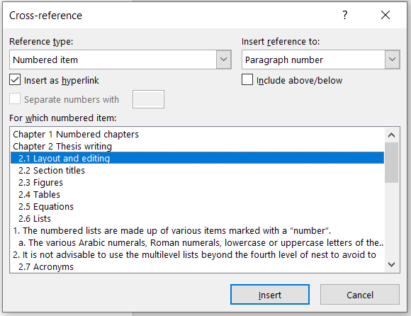
Figure 2.3 – Cross-references for the automatic numbering of sections

  - Figures
Figures that are used in the text to help the comprehension must be inserted in the paragraph with a centred-alignment. They should contain the caption just after (or before) the figure itself, but it must be placed within the same page. The caption can automatically be inserted by right-clicking on the figure and selecting ‘insert caption’. They need to be numbered in a progressive way, and it is advisable to use the chapter number followed by the progressive figure number of the current chapter (to make eventual changes during the editing easier). The figure numbering can be automatically reported if the caption is copied and pasted into a new figure and then updated the numbering.
Every figure must be mentioned and discussed in the text, e.g., “in Figure x.y it is shown…” (where x represents the Chapter number and y the figure one), avoiding expressions like “in the figure below” and similar. Even in this case, the numbering is automatically reported using the tool ‘cross-reference’. Each figure must be shown only after being introduced in the text (or in a nearby zone).
Obviously, in the case of a graphic, the dimensions in the horizontal and vertical axes, together with their measurement units (typically in square or round brackets), must be indicated. If more curves are reported, each of them must be clearly identified with different symbols, colours… and using a legend, such as the example shown in Figure 2.4.

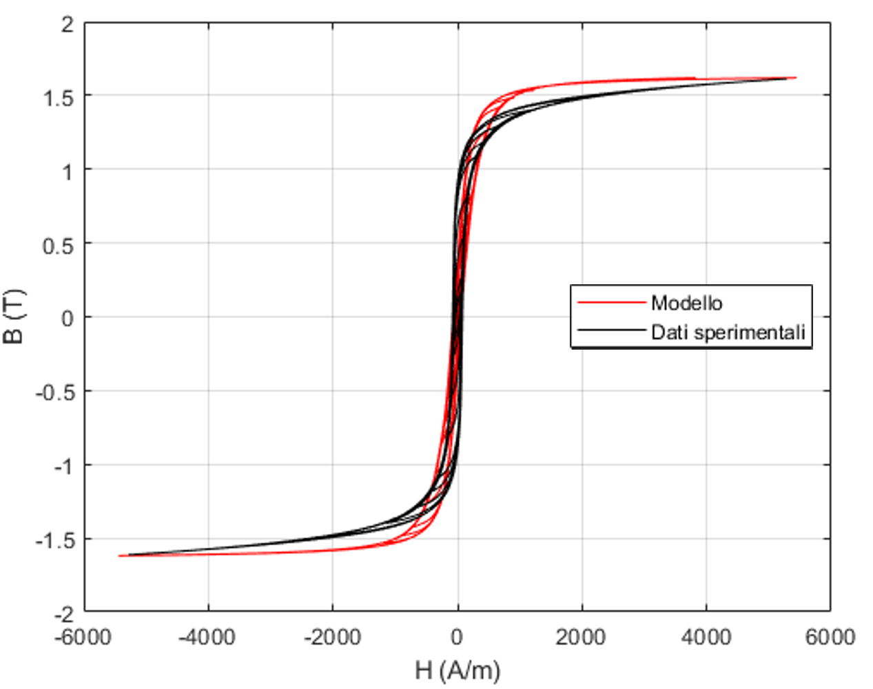
Figure 2.4 – Comparison between the hysteresis cycles based on experimental data and numerical model reported in the Appendix B for a doped Fe-Si at 3%. Figure from Grimaldi (2020)

The graphics should (preferably) have a white background. The use of colours could help the readability of the graph or could be necessary in some cases; however, when possible, it is convenient using different styles or markers that are distinguishable even in a black and white hardcopy. In view of this, the use of soft colours (yellow, light blue) should be avoided. It is worth mentioning that colour prints can be expensive, and double-sided printing requires the use of paper with an appropriate weight. In the case of colour-scaled images, such as the one resulting from Computational Fluid Dynamics (CFD) simulations, a proper scale should be chosen to avoid confusion between high and low values in the case of black and white reproduction.
The selected figures should be easily readable. The font dimension used in the figure should be large enough (but not too large, typically it should have the same font dimension as the caption or text) until the inscriptions can be legible. For example, the Figure 2.5 (a) is appropriate, meanwhile the labels on the axis in Figure 2.5(b) are not readable. It should also be noted as Figure 2.5(b) is extremely flattened. In order to keep the original aspect ratio, the ‘lock aspect ratio’ tool can be activated, as shown in Figure 2.6.
It is possible to insert figures taken by books, scientific papers, … only if a permission of the copyright holder has been granted, or if the figure has been significantly modified and the source is cited, e.g. writing in the caption “the figure was taken from [X] with modifications”, substituting [X] with the bibliographic reference (see Section 2.8).

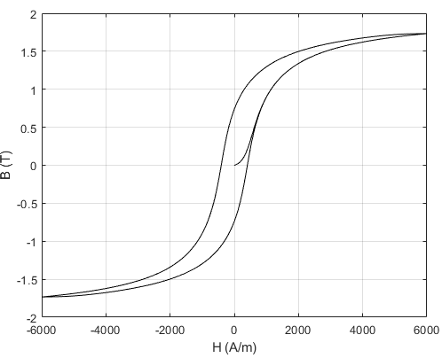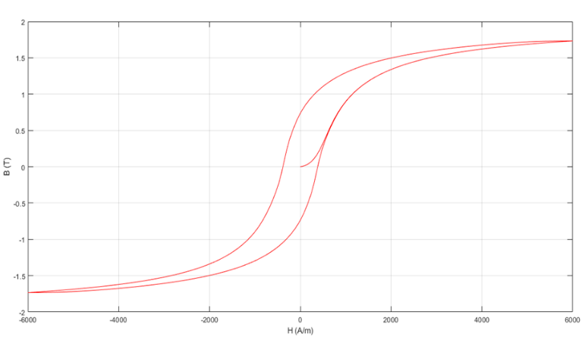
(a) (b)
Figure 2.5 – An example of picture with a readable (a) and not readable (b) text

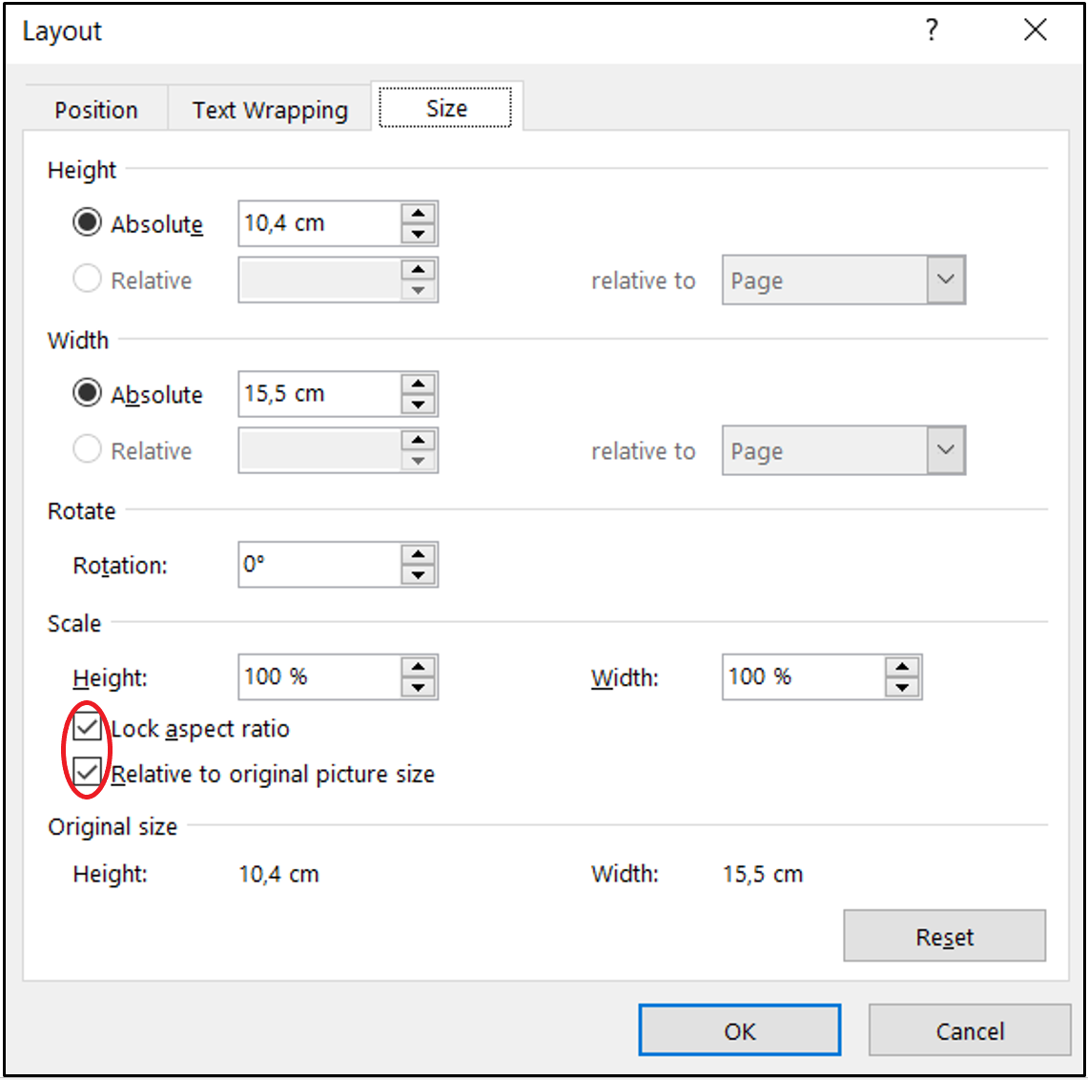
Figure 2.6 – Settings needed to lock the figure aspect ratio

  - Tables
As for the figures, even the tables should be considered as objects. Therefore, they should possibly be centred-aligned and progressively numbered, showing the chapter number in which they are inserted. Each table should be mentioned in the text and has to be reported only after being introduced in the text. Unlike for figures, the table “caption” is typically placed above the table itself, but it must be on the same page, as for the figures.
Tables must be clear: it is suggested to use the same type of font adopted in the text body. The first lines are dedicated to all (physical) quantities showed in the table with the related unit of measure, while the table body is filled by numerical data aligned (typically centre-aligned or left-aligned) in columns. The data must in turn be significant and must not be reported with too many decimal digits if compared to the variables being analysed, nor with a number of significant digits lower than the precision of the data themselves.
The symbol for separating the integer part and the decimal part of a number is the comma, not the point (dot); the decimal point is always used in American literature, while in Europe the rules establish the use of the comma. The point (dot) can only be used in sections of written text using a programming language, because in that case the rules of that language must be respected. For numbers greater than hundreds, the separator point of thousands must be strictly inserted. For theses in a foreign language, the rules of that linguistic context must be respected.
A possible template of a table is shown in Table 2.1, even though alternative variants can be realized (see for example Table 2.2).

Table 2.1 – This is a table template with few columns
Variable 1  [unit 1] | Variable 2  [unit 2] | Variable 3  [unit 3] | Variable 4  [unit 4]
X.XXX,XX | X.XXX,XX | X.XXX,XX | X.XXX,XX
XX,XX | XX,XX | XX,XX | XX,XX

Table 2.2 – This is a table template with many columns and data
Variable 1  [unit 1] | Variable 2  [unit 2] | Variable 3  [unit 3] | Variable 4  [unit 4] | Variable 5  [unit 5] | Variable 6  [unit 6]
X.XXX,XX | X.XXX,XX | X.XXX,XX | X.XXX,XX | X.XXX,XX | X.XXX,XX
X.XXX,XX | X.XXX,XX | X.XXX,XX | X.XXX,XX | X.XXX,XX | X.XXX,XX
X.XXX,XX | X.XXX,XX | X.XXX,XX | X.XXX,XX | X.XXX,XX | X.XXX,XX
XX,XX | XX,XX | XX,XX | XX,XX | XX,XX | XX,XX
XX,XX | XX,XX | XX,XX | XX,XX | XX,XX | XX,XX
XX,XX | XX,XX | XX,XX | XX,XX | XX,XX | XX,XX

  - Equations
If there is a need to insert an equation with automatic numbering, a table with two columns and invisible edges should be created. In this way, the equation can be inserted on the left column, while the equation number can be included on the right, allowing one to refer it in the text using a cross-reference. For example, the equation reference (2.1) can be obtained as explained in the note.
 | $$E=mc^{2}$$ | (2.1)
To reuse this scheme for other equations, the overall table must be selected (just click on the “cross” sign appearing on the left of the table area) and then copied and pasted in the desired position, remembering to update the numbering of the equation. To automatically cite it again in the text, the same procedure of figures and tables should be followed⁹.
In case a formula must be broken because too long, it can be done just after a relational operator (e.g., =, ≥, ...) or before a binary operator (e.g., +, -, ...). In any case, it must be remembered that a typographer would not know how to interpret the formula and would not know where to go to the end, but the author of a technical-scientific report exactly knows what he is writing and therefore must be able to choose the best position where to go to the end without breaking the rhythm of the mathematical expression.
When writing the equation, attention should be paid to the fact that the variables must be written in italics, the vectors in bold, while the numbers must NOT be written neither in italics nor in bold, even when they are subscript. For the equation editing, it is advisable the use of specific software, such as Equation Editor or MathType, since they generally allow to obtain a satisfactory result.
Finally, it should be remembered that each variable within the equation or formula must be explained, if not expressly previously done, without assuming that the reader knows the physics behind. For example, the well-known formula (2.2) should be made explicit with sentences like “the energy $E$ is given by the following expression:
 | $$E=mc^{2}$$ | (2.2)
where $m$ is the mass and $c$ is the light velocity in vacuum”. Alternatively, “The Einstein formula says…: where $E$ is the energy, $m$ is the mass, and $c$ the light velocity in vacuum”.
  - Lists
A typical structure of the technical-scientific writings is made by lists; there are two kinds of lists:
- numbered lists;
- bulleted lists.

When a list encloses another one, a multilevel list is created. Below there are some examples of all three list types that can be followed as a model. The numbered lists are made as follows:
- The numbered lists are made up of various items marked with a “number”.
  - The various Arabic numerals, Roman numerals, lowercase or uppercase letters of the alphabet can be used to distinguish the different nesting levels.
- It is not advisable to use the multilevel lists beyond the fourth level of nesting to avoid too complex structures.

The bullet list appears like this:
- The items in the marked lists are highlighted with symbols, as in the list in which this paragraph appears.
- The symbols are the same for all items belonging to the same level, thus they cannot be used to refer to a particular item.
- Marked lists can be nested at different levels (do not exceed the fourth level of nesting to avoid complex structures).
  - The markers of the various levels are different, and the left margins are conveniently shifted to the right (indented) as shown for the numbered lists.

A distance equal to an empty line must be maintained between a list and the next paragraph. If the object listed does not contain verbs or consists of a short sentence, it can end with a semicolon. Instead, if the object listed consists of one or more complete sentences with a certain extension, it can end with a full stop. Correspondingly, the sentence will start with an uppercase or lowercase letter depending on the used punctuation.

  - Acronyms
Acronyms are used to not overburden the discussion by avoiding the full extension of combined words or abbreviations (typically in English) that often occur in the text. They should be enclosed in round brackets, such as for example “il Presidente del Consiglio dei Ministri (PCM) is issuing a new Decreto del Presidente del Consiglio dei Ministri (DPCM)”. Instead, when they come directly from English terms, it is advisable to leave the original abbreviation, such as “the Wireless Power Transfer (WPT) is a new technology…”
Acronyms need to be specified only ONCE (the first time) when they appear in the text. Instead, it is a good practice not using them during the “Conclusions”, or at least to report the full acronym the first time, as for a separate or independent Chapter.
  - Bibliographical references
In writing the thesis, it is necessary to avoid any kind of plagiarism deriving from the insertion of text produced by others, without this text being placed in quotation marks; alternatively, it is possible to summarize parts of the works (published) by others, but it should be clearly stated that it is a summary by reporting the source. This text, however, must be limited to a few sentences or short passages. In the case of tables, figures, diagrams, etc, taken from other documents, the source must always be specified.
There are several types of bibliographical references; among them, it is important to distinguish between indexed references and grey literature. All those references with a unique code belong to the former, such as the International Standard Book Number (ISBN) for books, or the Digital Object Identifier (DOI) for articles in journals or conference proceedings, the patent number, or the series of a standard. On the other hand, all the documentation that is not identified with a unique code belongs to the latter. Grey literature is generally available and can be obviously cited. Examples are Project reports (including those published by some agencies), the conference proceedings themselves (if not indexed), degree and doctoral theses, or websites. In the latter case, if they are widely used, it is good practice to include them at the bottom of the bibliography (or in a subsequent chapter on its own called webliography).
Whatever the type it is, the source used to find information from others must be appropriately cited in the text. The style used for the citation may vary depending on the context, but once chosen, it is essential that it remains uniform and consistent.
In technical-scientific writings, the most used styles are mainly:
- the Harvard style;
- the style followed by the Institute of Electrical and Electronics Engineers (IEEE).

Regardless of the style used, which is at the discretion of the student, it is good to keep in mind some general rules. In the following, it is therefore described how to cite in the text a bibliographic reference both in Harvard and IEEE styles.

Harvard style
In Harvard style, the reference in the text is inserted indicating the author’s surname and the year of publication. In particular:
- the author surname followed by the year of publication, in the case of publications with a single name (e.g., “Sempronio, 2009”);
- the surnames of the two authors followed by the year of publication, in the case of publications with two authors (e.g., “Tizio and Caio, 2010”);
- the surname of the first author followed by the abbreviation et al. and by the year of publication, in the case of publications with more than two authors (e.g., “Caio et al., 2012”).

Example: “The technology under investigation has been described in various papers (Sempronio, 2009; Tizio and Caio, 2010; Caio et al., 2012). Sempronio (2009) also highlighted that the approach of Caio et al. (2012) ...”
When there are more publications in the same year with the same author, they can be indicated as follows: “Sempronio, 2009a”, “Sempronio, 2009b”, and so on. Similarly, it can be done in the case of publications with two authors or with more than two authors.
In the “Bibliography” chapter, it is necessary to list all the bibliographic references with the full information. These must be entered according to the alphabetical order of the surname of the first author. For publications that have the same first author, it is necessary to precede those with a single author, then those with two authors, and then the others. In publications with a single author, the order is chronological (starting from the oldest ones with the aid of the letter a, b, ... in the case of publications in the same year); similarly for publications with two or more authors.

IEEE style
In the IEEE style, also known as Vancouver, references in the text are instead cited using progressive numbering, where the identification number is usually inserted between square brackets. In this case, in the “Bibliography” chapter, the bibliographic references are listed in the order in which they are introduced into the text.
Example: “The technology under investigation has been described in various papers [1]-[3]. Sempronio [1] also highlighted that the approach of Caio et al. [3]....”
This citation method works well when a very large number of references is needed, especially for each single point, such as in review papers. However, it can create some troubles when few references must be inserted or deleted afterwards, forcing to renumber all the citations from that point onwards. Thus, in order to automate the insertion of bibliographic references, avoiding these inconveniences, additional packages compatible with Microsoft Word have been developed. Some of them, but not exhaustive, are EndNote or Mendeley, which are able to create different archives according to their own needs and choosing then the desired style.

Final recommendations
In order to minimize errors, it is always recommended to carefully reread what has been written before completing the thesis work. In addition to the content, grammar and punctuation, the layout and numbering of the figures, tables, equations, must also be double checked ... It would seem like an obvious recommendation, but reality often shows that students forgive this in practice. It is also strongly recommended to constantly save the file and make backup copies of it.
The use of the spelling checker is also recommended, although it does not replace, but only facilitates, the revision. This recommendation is especially valid for those who will use LaTeX instead of Word. Often, in fact, they do not use the spelling check.
Finally, it should be remembered that, despite the numerous guidelines, this document is intended to be only a vademecum far from being exhaustive. Rather, some details have been intentionally omitted in order to stimulate the creativity typical of the Engineer and develop in the student the inclination for problem-solving. It is worth pointing out that during our profession, we are now called to draft increasingly complex technical reports. These can be easily addressed only by demonstrating a good attitude towards “problem-solving”; conversely, they could be a source of great frustration.

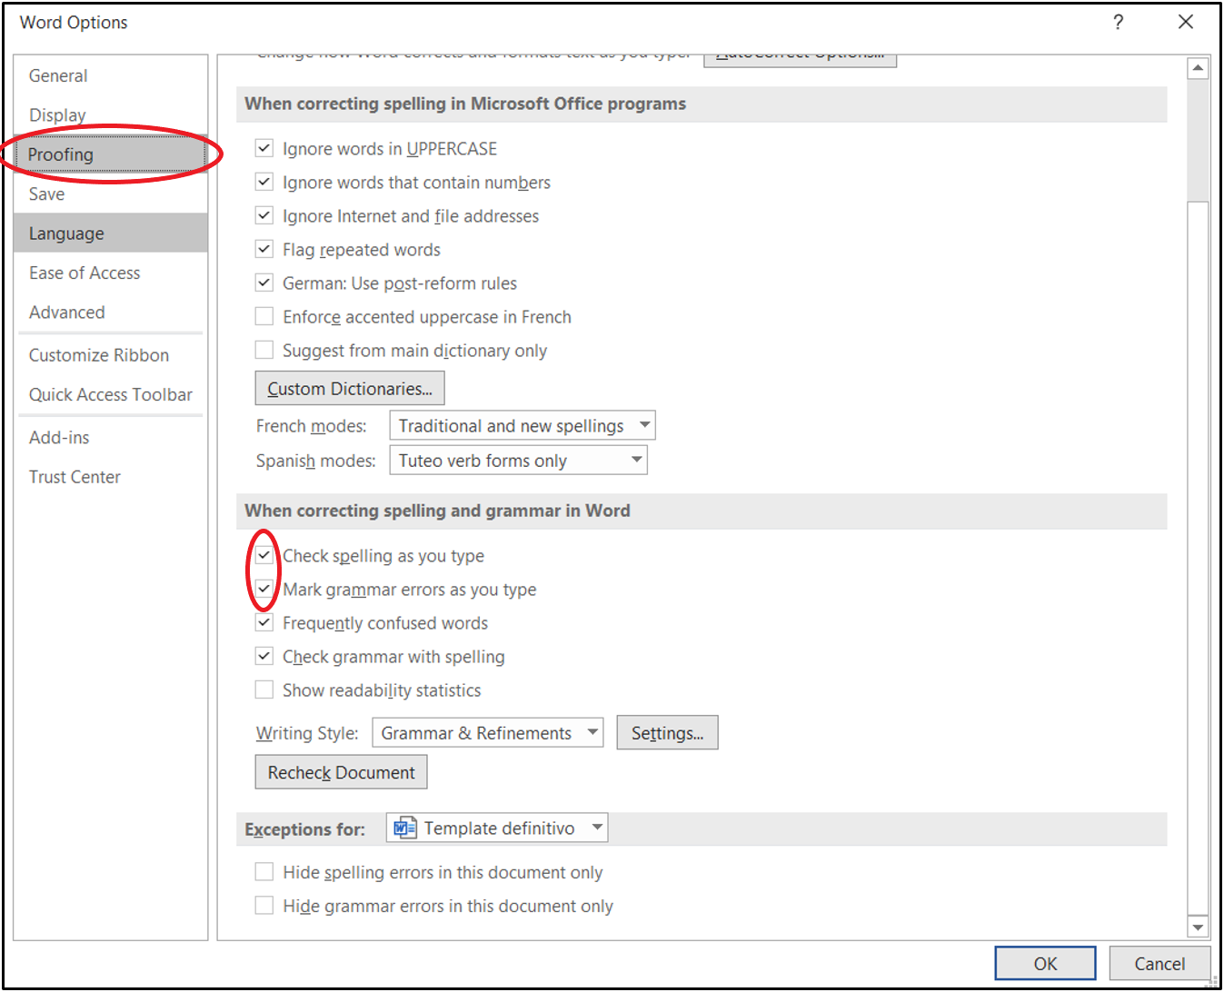
Figure 3.1 – Settings to enable the spelling and grammar check

Conclusions
The conclusions are an important part of the thesis, and therefore, they are reported in the last chapter. The conclusions summarize the main observations of the thesis. In particular, it is necessary to recall the method of reasoning followed in the work, reporting the relevant results that have been emerged.
The conclusions must be linked to the introduction; in them, it is necessary to justify the achievement or not of the objectives pre-fixed at the beginning of the thesis to derive limitations and possible future works of the research.

Future works
This latter issue may represent a real section if it is sufficiently articulated.

List of symbols
The list of symbols is optional, but highly recommended when the number of symbols is particularly large. Uppercase or lowercase symbols, both for units and for decimal prefixes, have radically different meanings and must be used correctly. The International System (SI) uniquely establishes whatever concerns the measurement units and therefore must be taken as a reference. Below there is an example of a list of symbols:

Symbol | Physical dimension | Unit | Dimension
h | Convective coefficient of heat exchange | watt over square meter per kelvin | W/(m² K)
J | Current density | ampere per square meter | A/m²
σ | Electric conductivity | siemens per meter | S/m
E | Electric field strength | volt per meter | V/m
ε | Electric permittivity | farad per meter | F/m
f | Frequency | Hertz | Hz
c | Light velocity in vacuum | meter per second | m/s
H | Magnetic field strength | ampere per meter | A/m
µ | Magnetic permeability | henry per meter | H/m
ρ | Mass density | kilogram per cubic meter | kg/m³
P | Power | Watt | W
PD | Power density | watt per square meter | W/m²
δ | Skin depth | meter | M
SAR | Specific absorption rate | watt per kilogram | W/kg
c_{p} | Specific heat at constant pressure | joules over kilogram per kelvin | J/(kg K)
T | Temperature | Kelvin | K
k | Thermal conductivity | watt over meter per kelvin | W/(m K)
Q | Thermal energy | Joule | J
λ | Wavelength | meter | M
W | Work | Joule | J

List of acronyms
The list of acronyms is optional, but highly recommended when a large number of acronyms is employed, in order to allow a reader to easily find them. It must be completed in alphabetical order. Below is reported the list of acronyms used in this document:

CFD: Computational Fluid Dynamics

DOI: Digital Object Identifier
DPCM: Decreto del Presidente del Consiglio dei Ministri

IEEE: Institute of Electrical and Electronics Engineers
ISBN: International Standard Book Number
ISO: International Organization for Standardization

PCM: Presidente del Consiglio dei Ministri

RTD: Resistance Temperature Detector

SI: International System of units

UNI: Italian National Unification

WPT: Wireless Power Transfer

Bibliography
The bibliography must contain a list of all the “paper” works explicitly cited within the thesis in progressive order, for the IEEE style, or alphabetic order, for the Harvard style. However, in the latter case, the alphabetic order will not be respected for the mere purpose of highlighting the specific format for the most common types of references.

IEEE Style
The following examples are taken from the IEEE Access template, available online at the link https://template-selector.ieee.org/
Multi-authors journal papers
Paper in a referenced journal
[1] W. P. Risk, G. S. Kino, and H. J. Shaw, “Fiber-optic frequency shifter using a surface acoustic wave incident at oblique angle,” Opt. Lett., vol. 11, pp. 115–117, Feb. 1986.

Paper in a referenced journal available online
[2] J. U. Duncombe, “Infrared navigation-Part I: An assessment of feasibility,” IEEE Trans. Electron. Devices, vol. ED-11, no. 1, pp. 34–39, Jan. 1959. [DOI: 10.1109/TED.2016.2628402]

Paper in press (but available online)
[3] P. Kopyt et al., “Electric properties of graphene-based conductive layers from DC up to terahertz range,” IEEE THz Sci. Technol., to be published. [DOI: 10.1109/TTHZ.2016.2544142]

Books, manuals and book chapters
Book example
[4] W.-K. Chen, Linear Networks and Systems. Belmont, CA, USA: Wadsworth, 1993, pp. 123–135.

Example of a book available online
[5] The Terahertz Wave eBook. ZOmega Terahertz Corp., 2014. [Online]. Available: http://dl.z-thz.com/eBook/zomega_ebook_pdf_1206_sr.pdf.

Example of manual
[6] Motorola Semiconductor Data Manual, Motorola Semiconductor Products Inc., Phoenix, AZ, USA, 1989.

Example of a book chapter
[7] G. O. Young, “Synthetic structure of industrial plastics,” in Plastics, 2nd ed., vol. 3, J. Peters, Ed. New York, NY, USA: McGraw-Hill, 1964, pp. 15–64.

Conference proceedings
Example of published volume as book
[8] D. B. Payne and J. R. Stern, “Wavelength-switched pas- sively coupled single-mode optical network,” in Proc. IOOC-ECOC, Boston, MA, USA, 1985, pp. 585–590.

Online publication
[9] PROCESS Corporation, Boston, MA, USA. Intranets: Internet technologies deployed behind the firewall for corporate productivity. Presented at INET96 Annual Meeting. [Online]. Available: http://home.process.com/Intranets/wp2.htp.

Normative Standard Publications
[10] IEEE Criteria for Class IE Electric Systems, IEEE Standard 308, 1969.
[11] Letter Symbols for Quantities, ANSI Standard Y10.5-1968.

Patents
Example of granted patent applications (date is that of grant)
[12] G. Brandli and M. Dick, “Alternating current fed power supply,” U.S. Patent 4 084 217, Nov. 4, 1978.

Example of granted patent applications (available online)
[13] Musical toothbrush with mirror, by L.M.R. Brooks. (1992, May 19). Patent D 326 189 [Online]. Available: NEXIS Library: LEXPAT File: DES.

Grey literature
Example of a PhD Thesis
[14] J. O. Williams, “Narrow-band analyzer,” Ph.D. dissertation, Dept. Elect. Eng., Harvard Univ., Cambridge, MA, USA, 1993.
Example of Degree Thesis
[15] A. Luciani, “Progettazione di un sistema di chiusura per la protezione ed allineamento del drone,” B.Sc. Degree, Department of Industrial and Information Engineering and Economics, University of L’Aquila, L’Aquila, Italy, 2018.

Example of Projects or Technical Reports
[16] E. E. Reber, R. L. Michell, and C. J. Carter, “Oxygen absorption in the earth’s atmosphere,” Aerospace Corp., Los Angeles, CA, USA, Tech. Rep. TR-0200 (4230-46)-3, Nov. 1988.

Presentation at congress, without publication or indexing
[17] D. Ebehard and E. Voges, “Digital single sideband detection for interferometric sensors,” presented at the 2nd Int. Conf. Optical Fiber Sensors, Stuttgart, Germany, Jan. 2-5, 1984.

Example of Licensed Software or Code or simple website
[18] MATLAB. 9.7.0.1190202 (R2019b). Natick, Massachusetts: The MathWorks Inc.; 2018. [Online]. Available: www.mathworks.com

Harvard style
Multi-authors journal papers
Paper in a referenced journal
Risk, W. P., Kino, G. S., Shaw, H. J., 1986, Fiber-optic frequency shifter using a surface acoustic wave incident at oblique angle. Opt. Lett., 11, pp. 115-117.

Paper in a referenced journal available online
Duncombe, J. U., 1959, Infrared navigation-Part I: An assessment of feasibility. IEEE Trans. Electron. Devices, 11 (1), pp. 34-39. [DOI: 10.1109/TED.2016.2628402]

Paper in press (but available online)
Kopyt, P. et al., Electric properties of graphene-based conductive layers from DC up to terahertz range. IEEE THz Sci. Technol., to be published. [DOI:10.1109/tthz.2016.2544142]

Books, manuals and multi authors book chapters
Book example
Chen W.-K., 1993, Linear Networks and Systems. Belmont, CA, USA: Wadsworth, pp. 123–135. [ISBN: XXX-X-XXXX]

Example of manual
Transmission Systems for Communications, 1985, 3rd ed., Western Electric Co., Winston-Salem, NC, USA, pp. 44–60.

Example of a book chapter
Young G. O., 1964, Synthetic structure of industrial plastics. in: “Plastics,” (J. Peters) 2nd ed., vol. 3, New York, NY, USA: McGraw-Hill, pp. 15–64.

Conference proceedings
Examples of published volume as book
Payne D.B., and Stern J.R., 1985, Wavelength-switched pas- sively coupled single-mode optical network. Proceedings of IOOC-ECOC, Boston, MA, USA, pp. 585-590.

Online publication
PROCESS Corporation, 1996, Intranets: Internet technologies deployed behind the firewall for corporate productivity. Presented at INET96 Annual Meeting, Boston, MA, USA. Web edition: http://home.process.com/Intranets/wp2.htp

Publications of Government Institutions and Agencies
The publications issued by institutions and organizations, without a personal author on the title page, are shown under the name of the institution or organization (even if the name corresponds to the publishing house).
ISO 8362-1, International Organization for Standardization, 1989. Injection containers for injectables and accessories - part 1: injection vials made of glass tubing. Geneva.
U.S. Department of Health and Human Services, Food and Drug Administration, 2004, Guidance for industry - A framework for innovative pharmaceutical manufacturing and quality assurance. available online at http://www.fda.gov/downloads/Drugs/ GuidanceComplianceRegulatoryInformation/Guidance/UCM070305.pdf

Patents
Examples of national and international patent applications (the date refers to that of the application) and of patents granted (the date is that of the grant)
Brandli G., and Dick M., 1978, Alternating current fed power supply. U.S. Patent 4 084 217.

Grey literature
Example of a PhD Thesis
Williams J. O., 1993, Narrow-band analyser. Ph.D. Thesis, Department of Electrical Engineering, Harvard University, Cambridge, MA, USA.

Example of Degree Thesis
Grimaldi L., 2020, Caratterizzazione numerica del ciclo d’isteresi di magneti permanenti. Tesi di Laurea, Department of Industrial and Information Engineering and Economics, University of L’Aquila, L’Aquila, Italy.

Example of Projects or Technical Reports
Reber E. E., Michell R. L., and Carter C. J., 1988, Oxygen absorption in the earth’s atmosphere. Tech. Rep. TR-0200, Aerospace Corp., Los Angeles, CA, USA, 3 Nov. 1988, pp. 4230-46.

Presentation at congress, without publication or indexing
Ebehard D., Voges E., 1984, Digital single sideband detection for interferometric sensors. Presented at 2nd Int. Conf. Optical Fiber Sensors, Stuttgart, Germany, Jan. 2-5, 1984.

Example of Licensed Software or Code or simple website
MATLAB 2018. 9.7.0.1190202 (R2019b), Natick, Massachusetts: The MathWorks Inc. www.mathworks.com

Webliography
The webliography is the systematic collection of Internet sites, or “digital” material, which had to be consulted for the writing of the thesis. Web references usually accompany bibliographic ones that are traditionally related to “paper” sources, although today most of the bibliographic references (books, articles, patents ...) can also be found in digital format. Below is an example of web references for the most common types.

Website
IEEE Access, https://template-selector.ieee.org/
Ministero della Salute: http://www.salute.gov.it/portale/home.html

Web page
Fortunato M. F., Scienze, La Repubblica, updated on 31/10/2019, https://www.repubblica.it/scienze/2019/10/31/news/lo_sapevate_le_opere_di_pollock_seguono_le_leggi_della_fisica-239982755/, accessed on 06/11/2019.

Article from a blog or web page
Zetti M., Il fatto quotidiano, Ebook, unire editoria digitale e podcast? Una bella sinergia dal cuore italiano, article date 06/11/2019, updated on 06/11/2019, https://www.ilfattoquotidiano.it/2019/11/06/ebook-unire-editoria-digitale-e-podcast-una-bella-sinergia-dal-cuore-italiano/5549130/, accessed on 07/11/2019.

- Numbered appendices
Afterwards, bibliographical references, eventual appendices can be inserted. An appendix can be useful, for example, to give a detailed description of a mathematical model whose numerous formulas can make heavy the body of the thesis.
The same thing may be applied to the results of very extensive measurement campaigns which, in order to not overburden the conventional chapters, find their natural place in the appendices.
The appendix is also the best place where to insert the listing of source codes of mathematical models developed as part of the thesis itself or of technical drawings or layouts of electrical circuits.
Finally, the appendix may contain facsimiles of tools used for data collection (e.g. surveys, application forms to register the time required for carrying out activities, etc.).

- Mathematical treatment
Mathematical treatments can be reported in Appendix B. The numbering of cross-references (figures, tables, equations …), must restart in progressive order according to the letter of the Appendix. To this aim, one needs to create a new label for each Appendix from the ‘References Insert caption’ tool, as shown in Figure B.1.

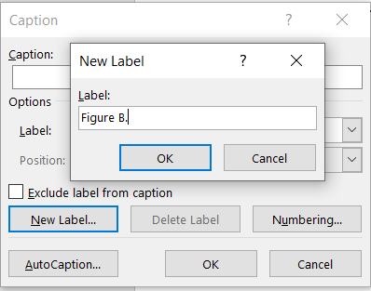
Figure B.1 – Settings for automatic numbering of Figures in the Appendix

This is an example of an Equation in Appendix. To recall it in the text, the same rules of the numbered Chapters can be applied, such as the equation (B.1)¹⁹:
 | $$E=mc^{2}$$ | (B.1)
  - Theorems
This is the style of a section in Appendix.
    - Corollary
This is the style of a sub-section in Appendix.

- Numeric codes
In this Appendix, all the codes (Matlab, C++, Python, …) related to numerical methods developed during the thesis work can be reported. As an example, a Matlab code used in Grimaldi (2020) is in the following illustrated.
  - Matlab code for the calculation of the Hysteresis cycle
    - Main Function of Jiles-Atherton (JA) model
The MIT License (MIT) Copyright (c) 2016 Roman Szewczyk
% Parametri iniziali del modello di JA
mi0=4.*pi.*1e-7;
Ms0=max(max(BmeasT))./mi0;
a0=5;
alpha0=1e-7;
k0=5;
c0=0.8;

JApoint0=[a0 k0 c0 Ms0 alpha0];
func = @(JApointn) JAn_loops_target(JApointn,JApoint0,HmeasT,BmeasT,1);
options=optimset('Display','iter','MaxFunEvals',500);

tic
JApoint_res=fminsearch(func,[1 1 1 1 1],options);
toc
Ftarget=func(JApoint_res);

BsimT = JAn_loops(JApoint0(1).*JApoint_res(1), JApoint0(2).*JApoint_res(2), JApoint0(3).*JApoint_res(3), ...
JApoint0(4).*JApoint_res(4), JApoint0(5).*JApoint_res(5),HmeasT, 1 );

fprintf('Results of optimisation:\n');
fprintf('Target function value: Ftarget=%f\n',Ftarget);
fprintf('JA model params: a=%f(A/m), k=%f(A/m), c=%f, Ms=%e(A/m), alpha=%e \n\n', ...
JApoint0(1).*JApoint_res(1), JApoint0(2).*JApoint_res(2), JApoint0(3).*JApoint_res(3), ...
JApoint0(4).*JApoint_res(4), JApoint0(5).*JApoint_res(5));

% Plot dei risultati
plot(HmeasT, BmeasT,'k',HmeasT,BsimT,'r');
xlabel('H (A/m)');
ylabel('B (T)');
grid;

JApoint_optim=JApoint0.*JApoint_res;

    - Function Jan_loops

INPUT:
% a - quantifica la densità dei domini, A/m
% k - quantifica l’energia media richiesta per rompere il “pinning
site”, A/m
% c - reversibilità della magnetizzazione.
% Ms - Magnetizzazione di saturazione, A/m
% alpha – Coefficiente di blocco
% H - Campo esterno applicato, A/m
% M0 - Valore iniziale della magnetizzazione, A/m

% SolverType – selezioni Il metodo di risoluzione delle ODE
% 1 - ode23()
% 2 - ode45()
% 3 - ode23s()
% 4 - rk4()
% OUTPUT:
% H - A/m
% B - T

if ((a<0) || (k<0) || (c<0) || (c>1) || (alpha<0))
fprintf('\n\n*** ERROR in JAn_loops: unphysical parameters.\n\n');
BsimT=zeros(size(HmeasT));
return
end % Controlla che siano fisici i parametri
BsimT=zeros(size(HmeasT));
InitialCurve=0;
if sum(HmeasT(1,:))==0
InitialCurve=1;
end

M0=0;

for lT=1:size(HmeasT,2),

H=HmeasT(:,lT);

if InitialCurve==0
H=[0; H];
end

[Hw,Bw] = JAsingle_loop(a,k,c,Ms,alpha,H,M0,SolverType);

if InitialCurve==0
Hw(1)=[];
Bw(1)=[];
H(1)=[];
Bw=Bw+linspace(0,Bw(1)-Bw(numel(Bw)),numel(Bw))';
Bw=Bw-(max(Bw)+min(Bw))./2 ;
end
BsimT(:,lT)=Bw;

end
end

- Experimental measurements
The data related to the experimental measurements can be reported in this Appendix.
  - Performed measurements

Table D.1 – Example of carried out measurements
#test | Flow rate hot fluid  [g/s] | Flow rate cold fluid [g/s] | T₁  [°C] | p₁  [bar] | T₂  [°C] | p₂  [bar] | T₃  [°C] | T₄  [°C]
2 | 93,7 | 126,4 | 50 | 88 | 108,28 | 180 | 391,65 | 329,63
3 | 84 | 88,6 | 50 | 88 | 108,28 | 180 | 334,13 | 273,96
4 | 104,8 | 136,3 | 50 | 88 | 108,28 | 180 | 381,49 | 319,82
5 | 49,8 | 40,2 | 50 | 88 | 108,28 | 180 | 295,24 | 236,10
6 | 68 | 73,1 | 50 | 88 | 108,28 | 180 | 337,64 | 277,37
8 | 140,5 | 195,1 | 50 | 90 | 108,28 | 180 | 400 | 337,69
10 | 1.170,8 | 1.237,3 | 50 | 90 | 108,28 | 180 | 400 | 337,69
12 | 1.139,5 | 1.193,8 | 50 | 90 | 108,28 | 180 | 400 | 337,69
13 | 999,9 | 1.103,1 | 50 | 90 | 108,28 | 180 | 330,01 | 269,95

  - Uncertainty analysis
Table D.2 – Example of uncertainty analysis on the carried out measurements
Quantity | Instrumentation (equipment) | Uncertainty
Torque | Torque meter Burster M20LK2 | 0,01 Nm
Velocity | Torque meter Burster M20LK2 | 0,01 %
Flow rate | Turbine flow-meter Riels R100 | 0,5% F.S.
Pressure | Piezoelectric transducer Gems | 0,00625 bar
Temperature | Resistance Temperature Detector (RTD) | 0,3 °C
Voltage DC | Voltmeter with Modbus channel | 1 V
Current DC | Ammeter | 0,001 A
Power AC | Tri-phase Power Analyzer PCE | 1 %

- Technical drawings
Technical drawing can be eventually reported also in the Appendix. For example, we hereby report two drawings developed during a bachelor degree thesis whose aim was the design and construction of a support basement for a wireless drone charging system [15].
  - Support basement
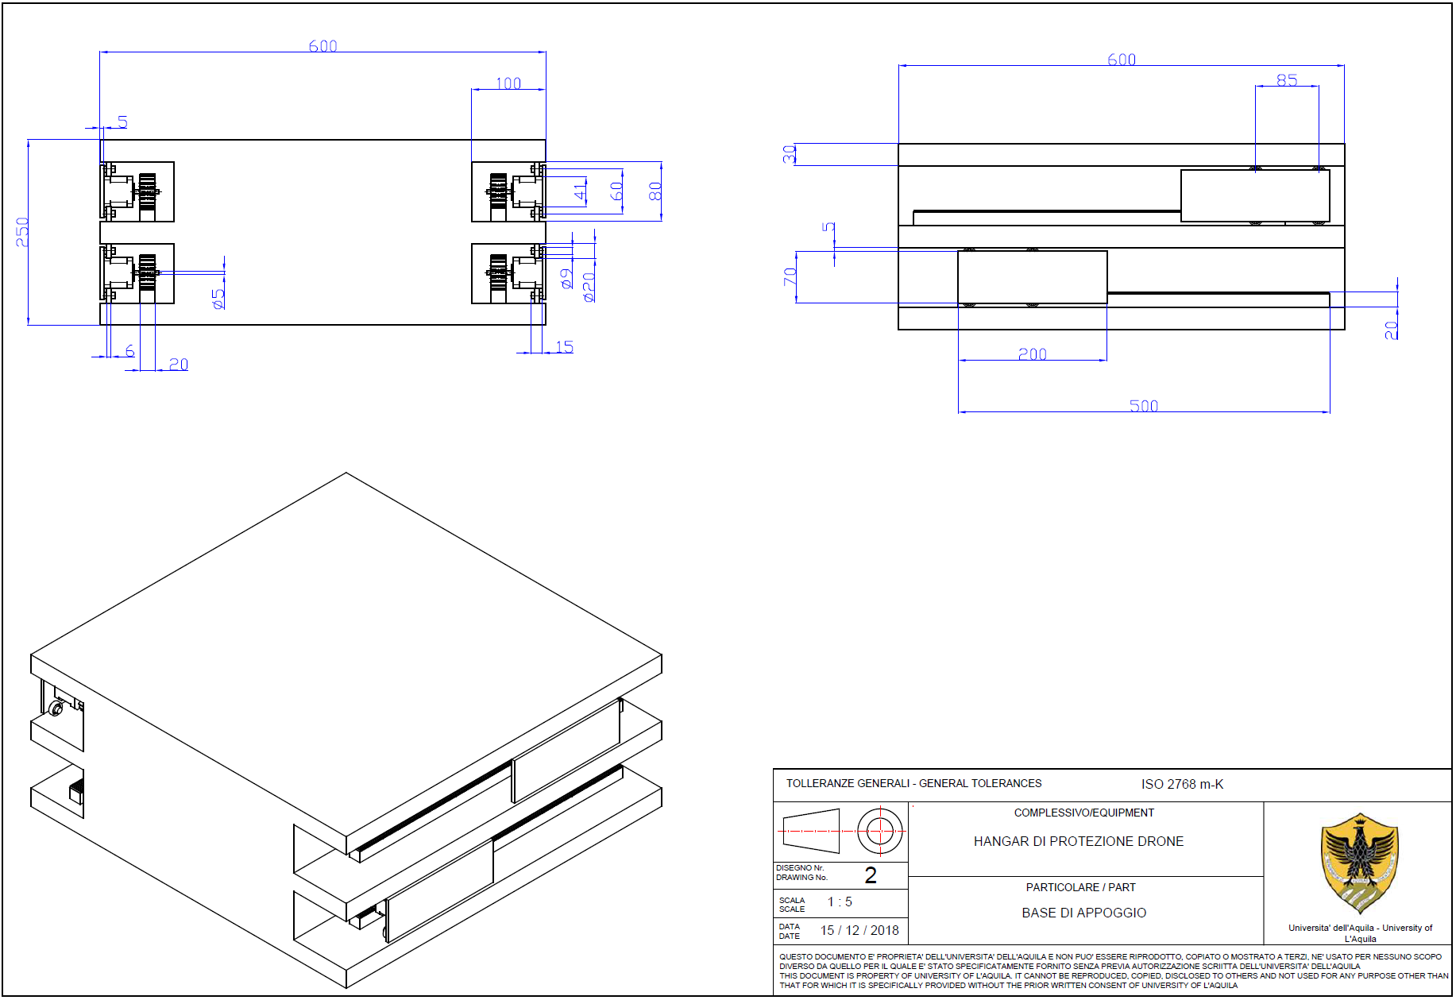
Figure E.1 – Drawing 1: support basement

  - Shell
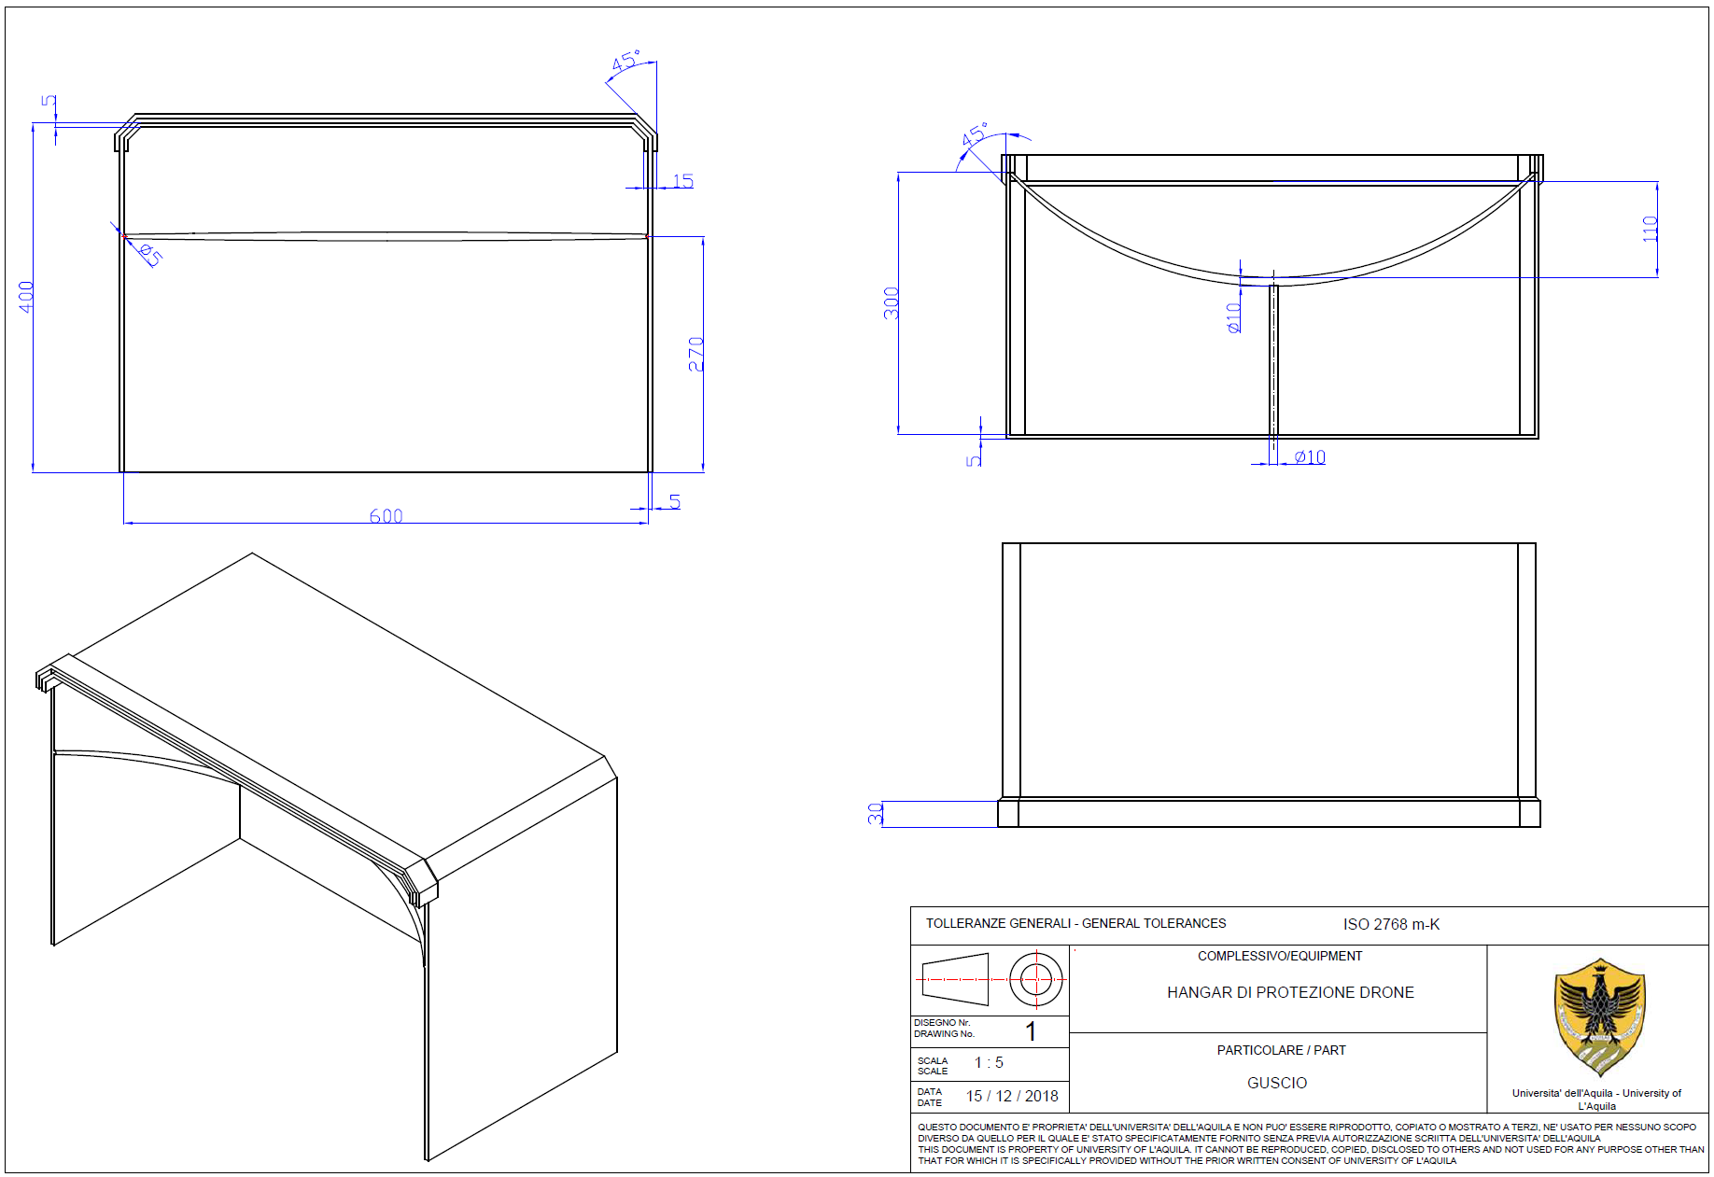
Figure E.2 – Drawing 2: shell

- Circuit Diagrams and Layouts
Some examples of circuit diagrams and layouts are illustrated in this Appendix.
  - Circuit diagrams
Figure F.1 – Circuit diagram

  - Circuit layouts
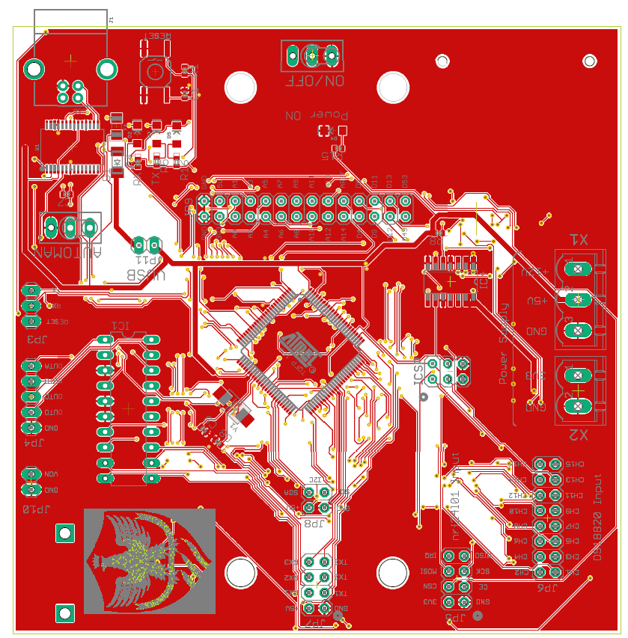
(a)
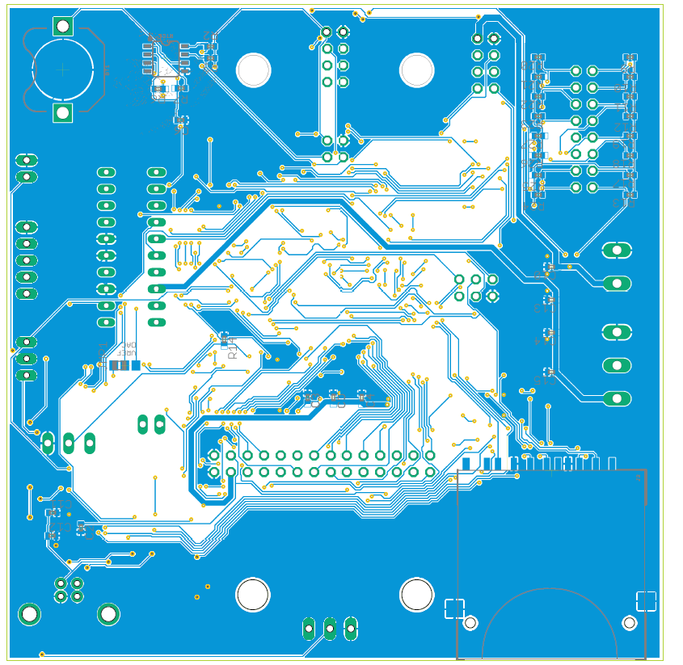
(b)
Figure F.2 – Circuit layout: (a) TOP view; (b) BOTTOM view

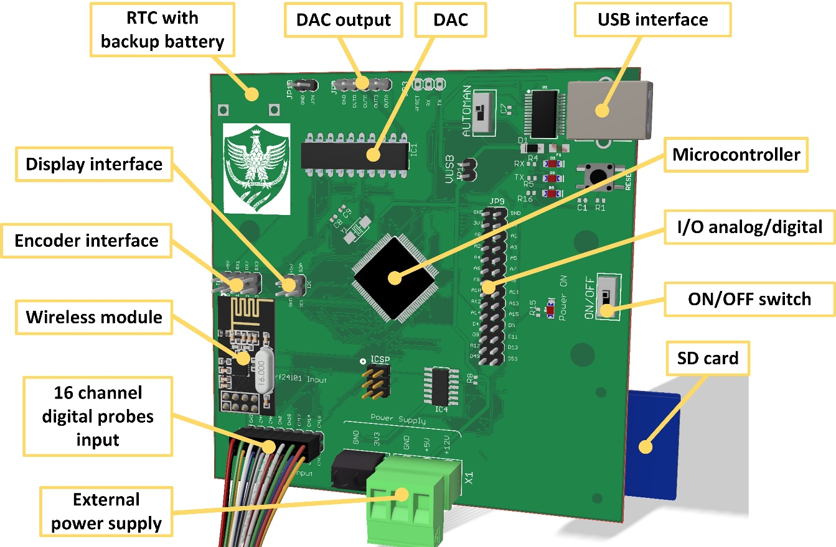
Figure F.3 – Detailed view of the prototype board.

- Chemical processes
Possible chemical processes can be reported in this Appendix. For example, a set of three reactions that take place in the same chemical process are hereby reported. It should be noted that such scheme can also be used in conventional chapters.
Table G.1 – Example of reactions that happen in a chemical process
CH_{4(g)} + H₂O_{(v)} ↔ CO_{(g)} + 3H_{2(g)} | ΔH⁰_{298 K} = 206.2 kJ mol⁻¹ | Reaction G.1
CO_{(g)} + H₂O_{(v)} ↔ CO_{2(g)} + H_{2(g)} | ΔH⁰_{298 K} = -41.2 kJ mol⁻¹ | Reaction G.2
CaO_{(s)} + CO_{2(g)} ↔ CaCO_{3(s)} | ΔH⁰_{298 K} = -175.7 kJ mol⁻¹ | Reaction G.3

Differently from sections and sub-sections, each Chapter must always start at a new page. To this aim, it can be used the tool ‘Insert Page Break’. Press also the ‘Shift+ Enter’ keys to wrap the title (or the name) of the Chapter.
In order to do that use the style ‘Objects’ among the Style list.
Place the cursor on the number that has to be updated, then right click ‘Update field’. In case the cross-references should be updated on the entire document, press Ctrl+A and then F9.
From the ‘cross-reference’ menu under reference type select ‘Figure’ and then the wanted figure.
Right clicking on the considered figure Size and position Size Lock aspect ratio.
It can be done automatically selecting ‘Table’ type from the cross-references and then the wanted table.
For this reason, it is called heading.
Taking into account the decimal prefixes that allow to avoid zeros at the beginning, it will be used as many significant digits as reasonable, based on the accuracy of the undertaken measurements; for instance, with accuracies of one percent of magnitude, two, or at most three, significant digits will be used.
It can automatically be done by selecting ‘Equazione’ type from the cross-references and then choosing the wanted equation.
Please note that the variables in the text are made with the same ‘math’ font of the equations.
Note the different style between consecutive citations and single ones. It should also be noted that, in case of citations with quoted text, the page number where the reference is made must also be indicated.
in order to avoid potential conflicts with the numbering of equations.
Note in this case the different style between consecutive citations, separated with a “-” symbol, and non-consecutive ones, separated with a “,” symbol (e.g. in [1], [5] and [7] it has been shown...)
Automatic spelling check (words underlined in red) and grammar (underlined in blue) should be enabled by default. However, if not enabled, it can be used the ‘File Option’ tool and settled the window in the way shown in Figure 3.1.
When the name of a measurement unit appears in a generic way, i.e. without a precise number, it must then be written in full and with lowercase letters (e.g.: “a voltage of several volts”).
The symbols are listed in alphabetical order by the name of the physical quantity. To automatically get it, just select the relevant column and then use the ‘Layout Sort data’ tool under ‘Table tools'.
Regarding the style of a “reference”, there is a specific ISO 690–1975 standard that regulates this matter. For Italy, there is the UNI 6017 standard, which clearly indicates what information must be included in a bibliographic reference, in what order they should be written and how they should be distinguished from each other.
The web reference typically follows the Harvard style, or the list in alphabetical order, so as not to overlap with the progressive numbering typical of the Vancouver or IEEE style.
For the generic Appendix X, one should create a label named ‘Table X.’ for Tables and a label named ‘X.’ for Equations.
Note that the numbering of the reactions is similar to that of the equations or other cross-references and therefore all all the rules of such a case should be followed.

